Extended Abstract Submission Form

Paper Title

Submission type | ☐Oral presentation  ☐Poster presentation
Theme | ☐Civil and Environmental Engineering  ☐Electrical and Information Engineering  ☐Mechanical and Manufacturing Engineering
Corresponding author:
Name:
Email:
Phone:
Presenter Details:
Name:
Title/Position:
Institution/Organization
Email:
Phone:

Title of Extended Abstract: Title of Article Should Concisely and Accurately Represent the Work Presented (Title)
First Author^{*(1)} (Surname with Initials), Second Author ⁽²⁾, and Third Author ⁽³⁾
⁽¹⁾ Affiliation Institution 1 (acronyms in institution names are not recommended), City.
⁽²⁾ Affiliation Institution 2 (acronyms in institution names are not recommended), City.
⁽³⁾ Affiliation Institution 3 (acronyms in institution names are not recommended), City.
E-mail:
Abstract: This document contains a detailed guideline for the extended abstract format of the Annual Research Symposium to be held on 20th March 2020 at the Faculty of Engineering, University of Ruhuna. A concise abstract is required. The abstract should state briefly the purpose of the research, the essential new information, the principal results, and major conclusions. The abstract must be able to stand-alone and references to the manuscript should therefore be avoided. The number of words should be between 100 to 150 words.
Keywords: Annual Research Symposium; Extended abstract; Formatting; Style; Template (List maximum of 5 keywords in alphabetical order separated by semicolon and a space)

Introduction (Heading 1)
This is a template for submissions to the ARS 2020. All submissions must adhere to the guidelines provided in this template. This is an example of the final manuscript which must be not greater than three pages including figures. The various components of your extended abstract [title, text, heads, etc.] are already defined on the style sheet, as illustrated by the portions given in this document.
Please use A4 size paper; in one column format with “Times New Roman” font. Margins are as follows; Top: 2cm; Bottom: 2 cm; Left: 2.5 cm; Right: 2 cm. Header set at 1.2cm and Footer at 1cm from the page limit, respectively. All margins, column width, line spaces, and text fonts are prescribed; please do not change them.

Template Specifications
This section provides the examples of extended abstract components. Please preserve the style of the headings, text font, and line spacing in order to provide a uniform style for the Proceedings.

Authors and Affiliations
Authors’ names are set in 10pt and no spacing before and after. Underline the corresponding author’s name and provide the corresponding author’s email address. Affiliation and contacts are in 9pt italics, with a spacing of 6pt before and after.

Headings (Heading 2)
Headings are used to organize the abstract in coherent manner. Style for component heads, i.e, Abstract, Acknowledgements, and References is given in “ComponentHeads”.
Text heads organize the topics on a relational basis. Title is the primary text head on which subsequent material is elaborated. Type the title of the paper in 12pt boldface, with a spacing of 12pt before and after. Styles “Heading 1” , “Heading 2”,and “Heading 3” are prescribed for sub-topics or the next level heads.
Capitalize all major words in the title and headings.

Body of texts (Text)
The normal texts should be set in 10pt “Times New Roman” with a spacing of 6pt after. Lines are single-spaced. The paragraphs should be justified.

Figures, Tables, and Equations
Figure captions should be below the figures and table captions should appear above the tables. Insert figures and tables after they are cited in the text. Tables and figures should be numbered consecutively.

Tables (Heading 3)
Tables should be designed to have a uniform style throughout the paper, following the style shown in Table 1.
Table 1. Caption heading placed at the top of the table and within table width.
 | A | B | C | D
A | Aa | Ab | Ac | Ad
B | Ba | Bb | Bc | Bd
C | Ca | Cb | Cc | Cd
D | Da | Db | Dc | Dd
E | Ea | Eb | Ec | Ed

Equations
Equations should be centered and numbered consecutively, as in Eq. (1).
$$\frac{P_{1}}{ρg}+\frac{V_{1}^{2}}{2g}+Z_{1}−h_{L}=\frac{P_{2}}{ρg}+\frac{V_{2}^{2}}{2g}+Z_{2}\left(1\right)$$

Figures
Authors are advised to prepare their figures in black and white. Please prepare the figures in high resolution (300 dpi) for half-tone illustrations or images. Figure 1 shows one example. When applicable, the texts in graphs, illustrations or images should be set in 10pt “Times New Roman”.
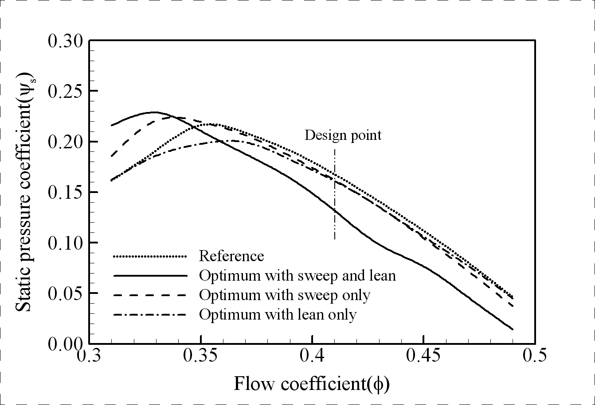
Figure 1. The caption heading for a figure should be placed below the figure and within figure/illustration width.

Units
Use SI units throughout the paper.

Extended Abstract Submission
Authors are invited to submit extended abstracts not later than 10th February 2020. Papers should be submitted in MS Word format (.doc or .docx) to the email address ars@eng.ruh.ac.lk with the submission form. Authors will be notified of their submission by 1st March 2020. The accepted extended abstracts should be revised according to the reviewers’ suggestions and final revised extended abstracts should be submitted within 06th March 2020.

Acknowledgments
Acknowledge the funding bodies and contributors, for the work described. We appreciate the cooperation and efforts of all authors in producing the Proceedings.

References
References should appear at the end of the paper according to Harvard style, listed alphabetically by last name of the first author. Thereafter sorting is made by co-authors and year. However, in the text, sorting is done by year (Abc et al., 2005; Ghi, 1992). References in the text consist of the author name and publication year in parentheses. All references listed should be cited in the text.
Example reference citations are provided at the end of this paper.
Journal articles
Last name, First initial. (Year published). Article title. Journal, Volume (Issue), Page(s).

Conference papers
Last name, First initial. (Conference Year). Title of Paper or Proceedings. In: Name or Title of Conference. City: Publisher of the Proceedings, pages.

Books
Last name, First initial. and Last name, First initial. (Year published). Title. City: Publisher, Page(s).

Daniels, K., Patterson, G. and Dunston, Y. (2014). The ultimate student teaching guide. 2nd ed. Los Angeles: SAGE Publications, pp.145-151.
Fox, R. (2014). Technological Advances in Banking. In: American Finance Association Northeast Regional Conference. Hartford: AFA, p. 24.
Ross, N. (2015). On Truth Content and False Consciousness in Adorno’s Aesthetic Theory. Philosophy Today, 59(2), pp. 269-290.

